# Summary

For the problem 01, I make two function. First function gives the train position according to train speed and time. Second function the car position and taking the input parameter car speed and acceleration and time. In each function is use the equation which are give the initial value when we pass t=0. In every iteration we take increment in time with 30 seconds. We want to maintain the matrix of all value and for the third columns of the matrix, I calculate the distance between train and car. For the distance we can use the distance formula which take x and y parameter and give the distance between point, in our case x and y are the car and train. For the last columns we need to find the car speed, for the car speed and car acceleration. For the plotting I use the subplot because it is mention in hint. We can use in one plot by using command hold on also. I plot all value in subplot one by one and maintain the legend and axis as well.

In the problem 02, we need to find the maximum, minimum and average from each column. We can find minimum, maximum, and average by using the build in function. At the end we compute the mean of each row and append the matrix A with the average.

# Question 01

## Code

clc

clear all

close all

% part a

u_car = 28; % miles per hour

u_train = 54; % miles per hour

acc_car = 4; % feet per second squared

res = zeros(11,5); % result matrix of dimesions 11x5

% time, train_pos, car_pos, dist_train_car, car_speed,

t=linspace(0,300,11);

for i=1:11

res(i, 1) = t(i);

res(i, 2) = pos_train(u_train, res(i, 1));

res(i, 3) = pos_car(u_car, acc_car, res(i, 1));

res(i, 4) = sqrt(res(i, 2)^2 + res(i, 3)^2);

res(i, 5) = u_car + acc_car * res(i, 1);

end

display(num2str(res));

% part b

[short_dist,ind]=min(res(:,4));

disp(['shortest distance between tran and car is ',num2str(short_dist),' at time ', num2str(t(ind)),' sec'])

% part c

syms time

inter = -150 + u_car*5280/3600 * time + (1/2) * acc_car* time * time;

inter=solve(inter,time);

inter=inter(find(inter>0));

time=(sqrt(40591)-154)/15;

train_pos=pos_train(u_train,time);

disp(['car cross the intersection at ',num2str(time),' and train at ',num2str(train_pos)])

% part d

subplot 221

plot(res(:,1),res(:,2),'k--','LineWidth',.2)

xlabel('time')

ylabel('train position')

title('train position')

legend('train position')

subplot 222

plot(res(:,1),res(:,3),'r-','LineWidth',.4)

xlabel('time')

ylabel('car position')

title('car position')

legend('car position')

subplot 223

plot(res(:,1),res(:,4),'b:','LineWidth',.6)

xlabel('time')

ylabel('dist train car')

title('dist train car')

legend('dist train car')

subplot 224

plot(res(:,1),res(:,5),'go','LineWidth',.8)

xlabel('time')

ylabel('car speed')

title('car speed')

legend('car speed')

## function code

### Train position

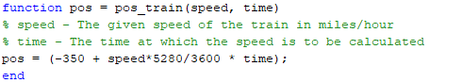

### Car position

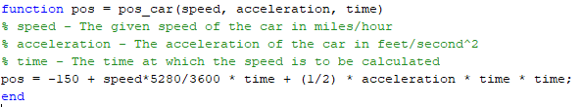

## Output

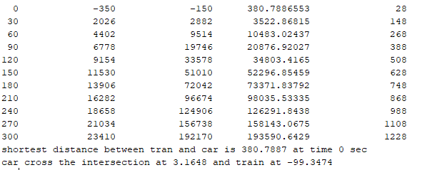

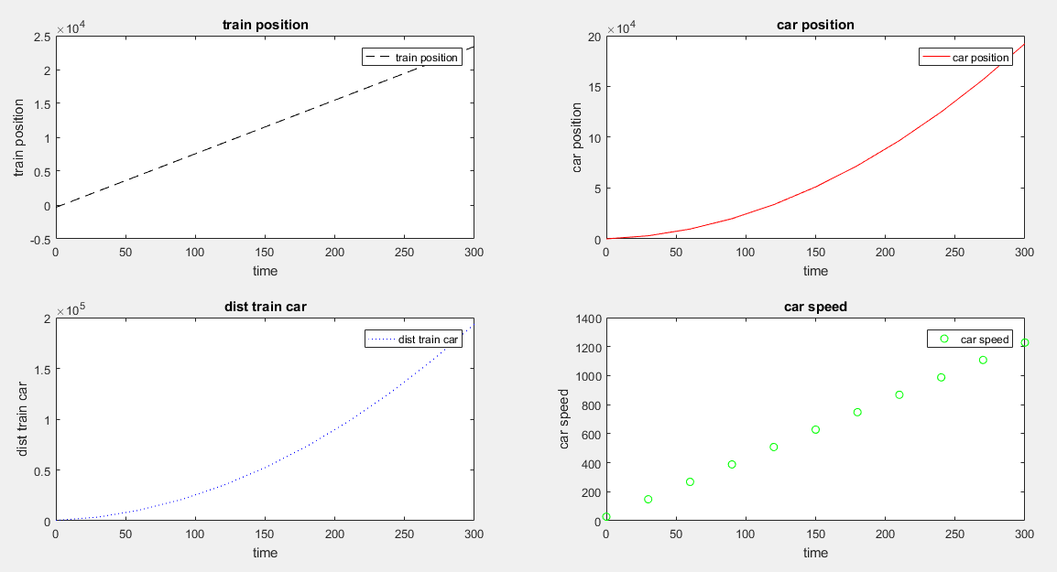

# Question 02

## Code

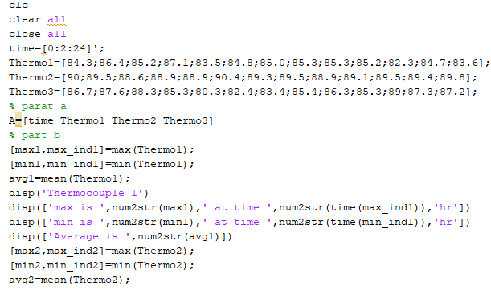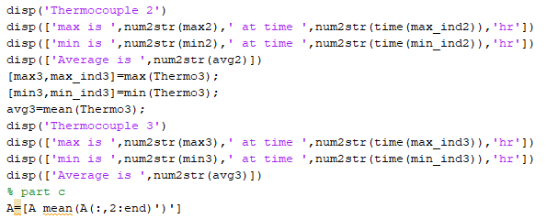

## Output

